Screenshot of Login Page and Creation of new account:
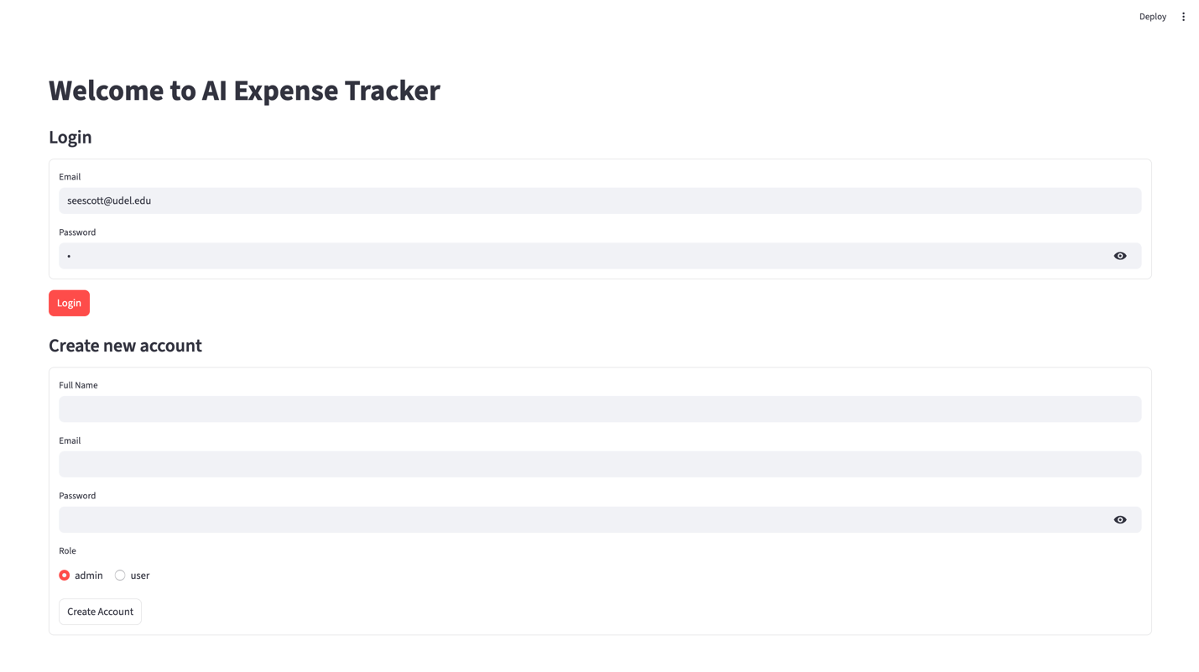
Full Expense Dashboard showing summary, expenses by category, highest and lowest expenses, and all expenses. (accessible to admin and user)
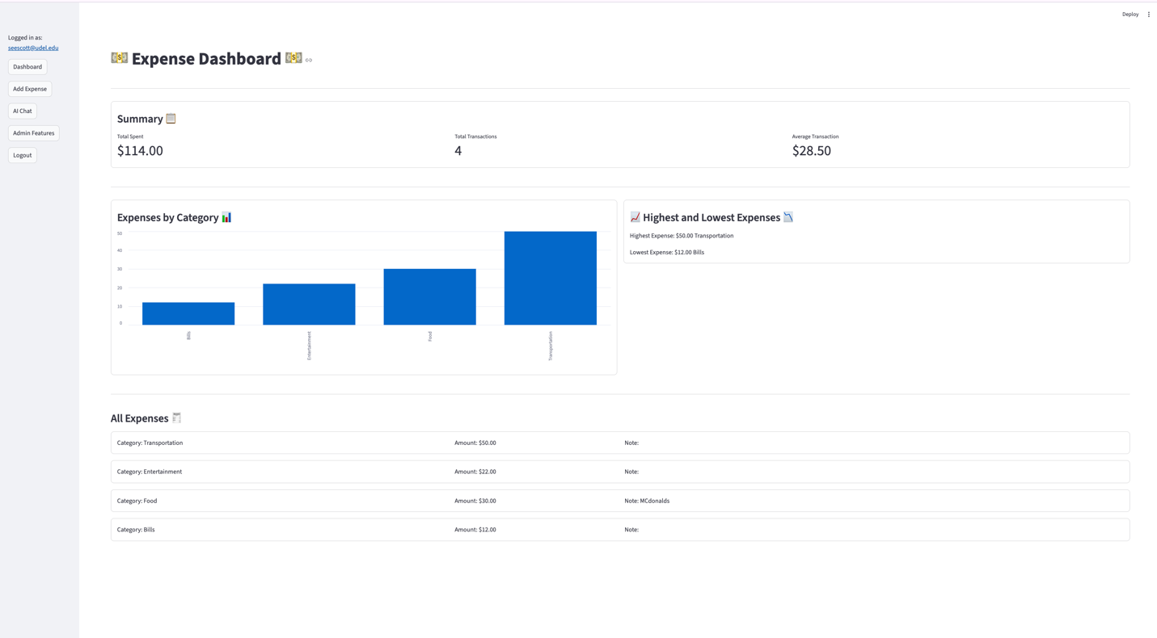

Adding new expense feature where you can change amount, category and put a note
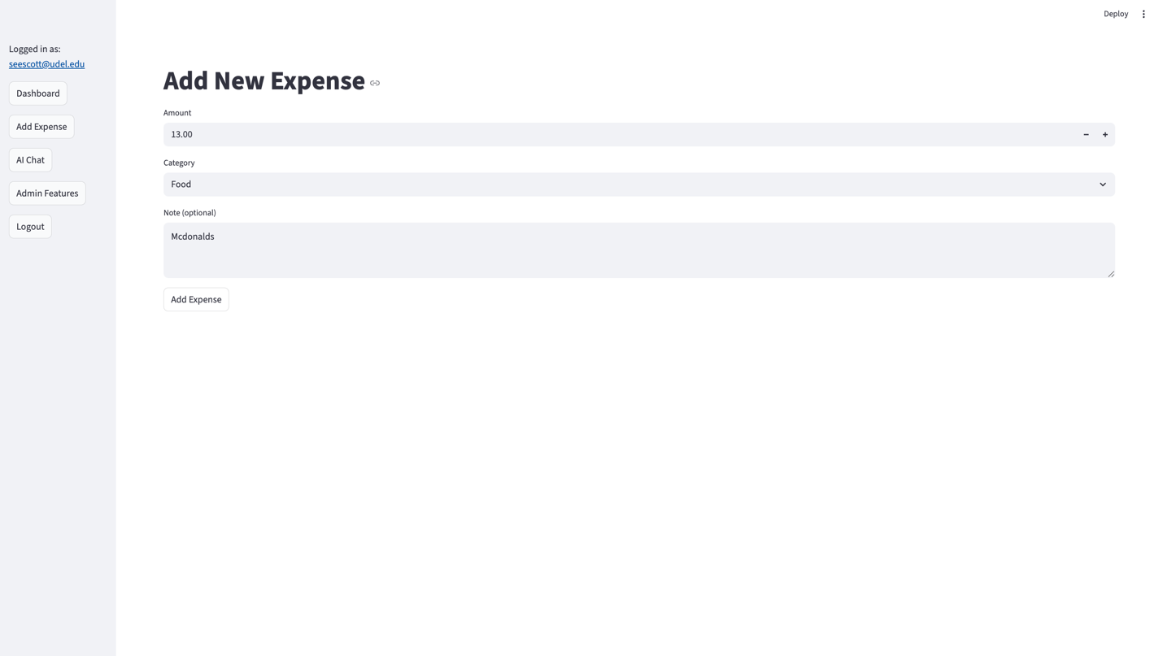
AI assistant feature
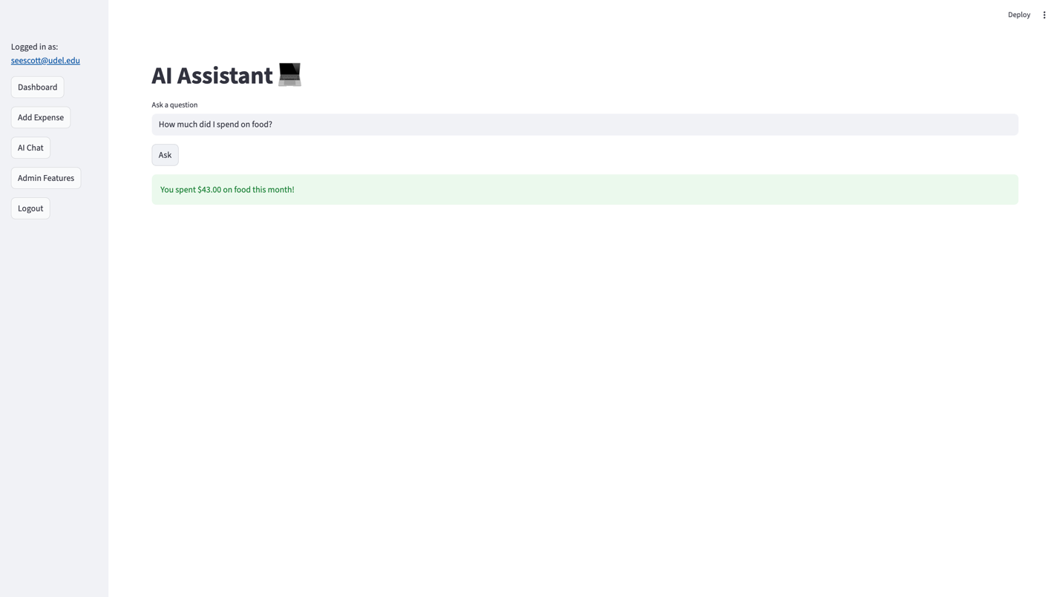

Admin Dashboard features where only admin can go in and select a user to edit or delete their expenses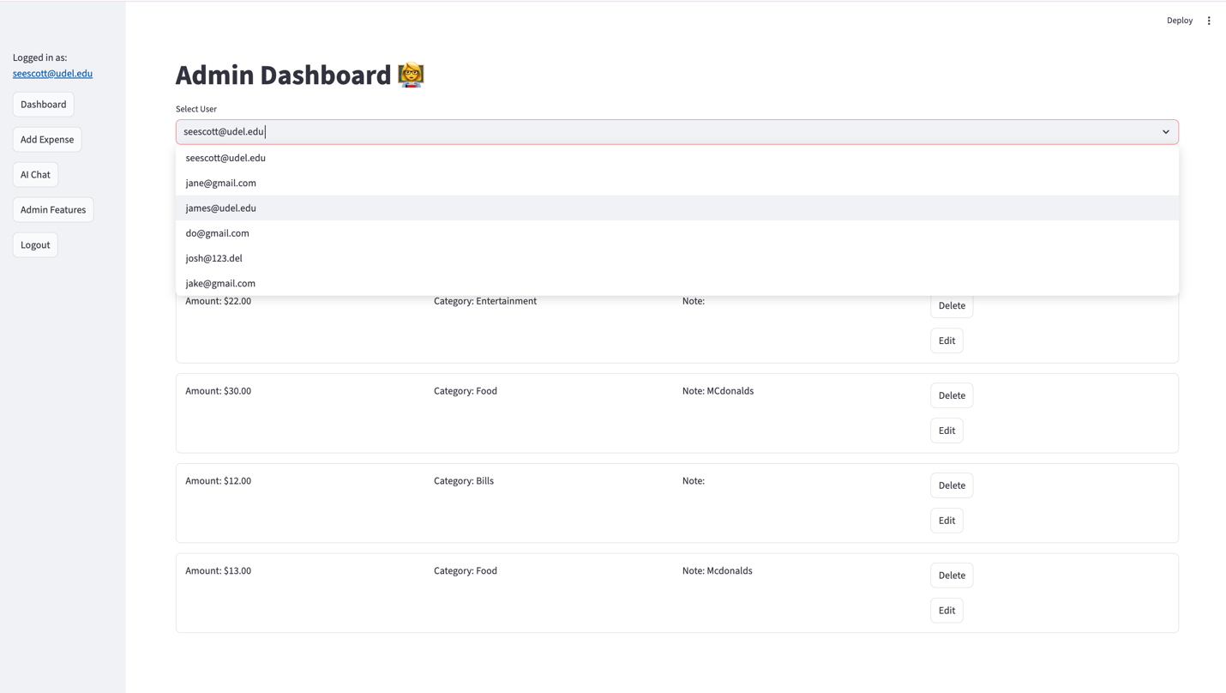
Edit expense feature where admins can go in and edit both their own expenses and other users
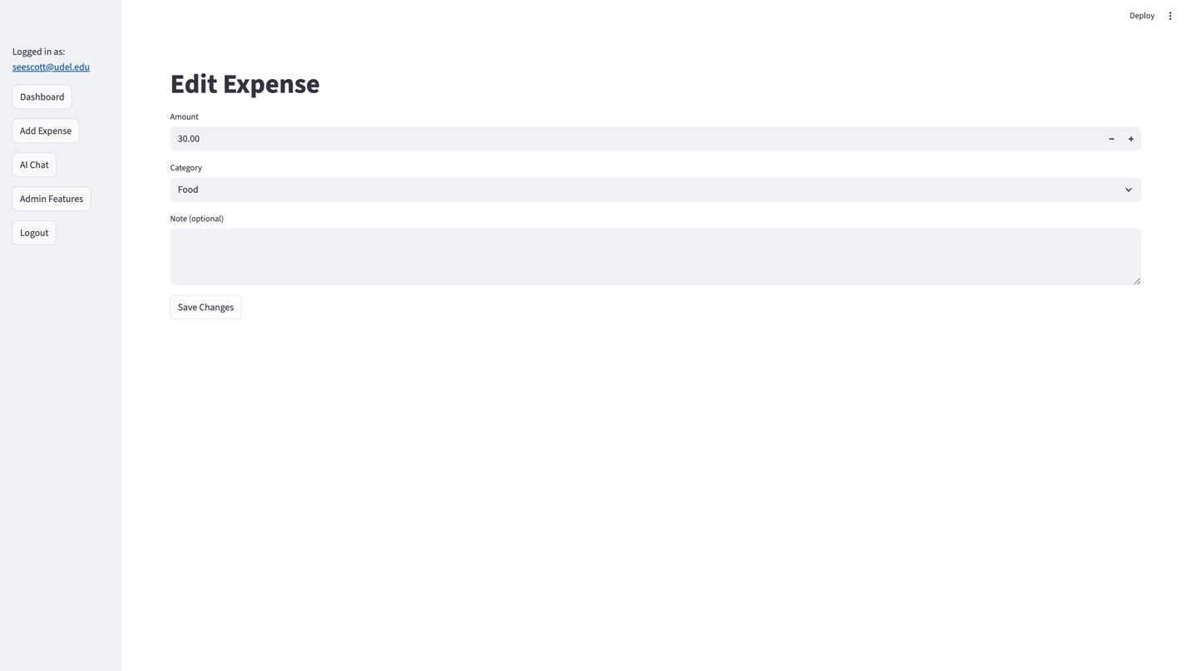
Logout button returns the user to the login page

